

Word Template for Computer-Aided Design and Applications Journal
John C. Gotti¹ , Jessie A. James² and Donald L. Corleone³

¹City University of New York, gotti@cityuny.edu
²Texas State University, Jessie@tsu.edu
³DLC and Associates, don@dlc.com

Corresponding author: John C. Gotti, gotti@cityuny.edu

Abstract. This document outlines the necessary details to prepare a paper for the Computer-Aided Design and Applications journal. Authors are requested to follow all formatting instructions encoded into this MS Word file. To simplify the task of document preparation, enter your paper into this file by substituting equivalent titles and paragraphs of instructions with your technical text.

Keywords: select at least three words or phrases that best describe your paper.
DOI: https://doi.org/10.14733/cadaps.YYYY.aaa-bbb

INTRODUCTION
This template file contains all relevant information to process papers into the proper format for the journal CAD and Applications. Either type your paper directly into this file, substituting appropriate paragraphs and headings, or bring in your text in a plain format and then change it to the appropriate style by simply selecting the intended style from the menu in the MS Word toolbar. Please do not change the preset styles.
The following sections summarize the parameters used in the various pre-set styles. You should never really have to deal with these parameters directly, but only select one of the pre-formatted styles. But for completeness of documentation, this information is given here so that future managers of this template may more easily make selective changes to some of the styles.
In general, a first paragraph (style Paragraph_first) after a title, figure, or table is not indented; but subsequent paragraphs following ordinary paragraphs (style Paragraph_following) have their first line indented by 0.25 inches.

PAGE SETUP
This MS Word template sets up each page; however, in case of settings get lost, here are the details:
- Paper size: 7.5" by 10.3"
- Top and bottom margins: 1"
- Left and right margins: 0.6"
- Headers and footers are 0.5" from the edge
- Column format: one column
Page numbers have been included already and will be adjusted when the paper is desk-edited for publication. Please do not remove or edit the page numbers!
The header block of each paper is preformatted with a header figure and two extra lines of text. This is followed by a 12-point bold title, which should be no longer than one line, or at most two, if it is absolutely necessary. Throughout the whole paper, the font Sans Serif is used. Only well-known abbreviations are allowed, such as NURBS, STL, or IGES. The initial letters of each word should be capitalized, except for the, a, and, or, for, in, from, etc.
Authors and affiliations are again in 9-point Sans Serif – as is most of the paper. Please add the ORCID hyperlink to the ORCID icons. A single blank line separates authors and affiliations.
This is followed by the abstract, which both carry their built-in spacing from the previous text elements. The abstract is indented on both sides by 0.5". It should be kept short.
The abstract block also carries the Keywords and DOI entries, separated by a single blank line from the abstract.

main text
The main text is in a one-column format based on 9-point Sans Serif. The ordinary text should be placed left and right justified throughout the paper.
The main text consists primarily of paragraphs and headings, and these all carry their spacing to the previous text elements; they also call for the most likely subsequent paragraph style. Of course, this can be overridden by simply selecting an item and pulling down a different style from the toolbar menu. The main headings are all in BOLD CAPITALS. They should be consecutively numbered, starting with 1 (which is done automatically with the style 1 HEADING_1).

Subsection Headings Use the Capitalization Rules of the Main Title
The subsection heading should also be in 9-point Sans Serif bold, flush left; however, only the initial letters should be capitalized. Note that for subsections and sub-subsections, the words the, a, and, in, for, etc. are not capitalized unless they are the first words.

Sub-subsections use mostly lower case
Sub-subsections can be used to give the document an additional hierarchical structure. But deep hierarchies should be avoided. Don’t use more than three hierarchical levels of headings. Sub-subheadings have only the initial letters capitalized. This applies to all sub-subsections, e.g., 3.1.1.1 or 3.1.1.1.1, etc. -- if you absolutely must use them.

Figures and Tables
The insertion of figures and tables requires special attention. First, each figure must be inserted where it belongs, as close to the figure reference as possible. Second, the selection of the file type makes a big difference in the file size of your paper. Please use the following formats:
- Bitmaps: JPG
- Line drawings: any line drawing format, e.g., PS, EPS, WMF, PNG.
Please do not scan line drawings as bitmaps! It takes a huge file to get adequate quality!
Third, the image resolution does not have to be high for good-quality publishing. As a rule of thumb, no need to go higher than 300 pixels per inch. Finally, and most importantly, please scale the image down to the size of your MS Word document, with a 100% paper size window, before inserting the picture. That is:
- estimate the image size in your MS Word document;
- scale the image down using an image processing software, e.g., MS Photo Editor;
- save the scaled-down image into a temporary folder; and
- insert the scaled-down picture into your paper.

IF THE FIGURES ARE IMPROPERLY PROCESSED, an MS Word document can be as large as 10 MB, but still, convey no more than 1 MB worth of information! Figures should be inserted centered. You may want to insert them side-by-side if they are logically linked together to save space. Color, as well as black and white images, are accepted. Each figure (group) must include a caption set in 9-point Sans Serif. The caption must be centered if it is short; otherwise, it is left and right justified. Figure numbering and referencing should be done sequentially, e.g., Figure 1, Figure 2, etc., for single figures, Figure 1(a), Figure 1(b), etc., for figures with multiple parts. Put a blank line before and after the figure.

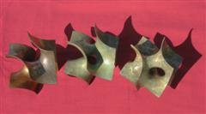

Figure 1: Short, centered caption, terminated with a complete stop.

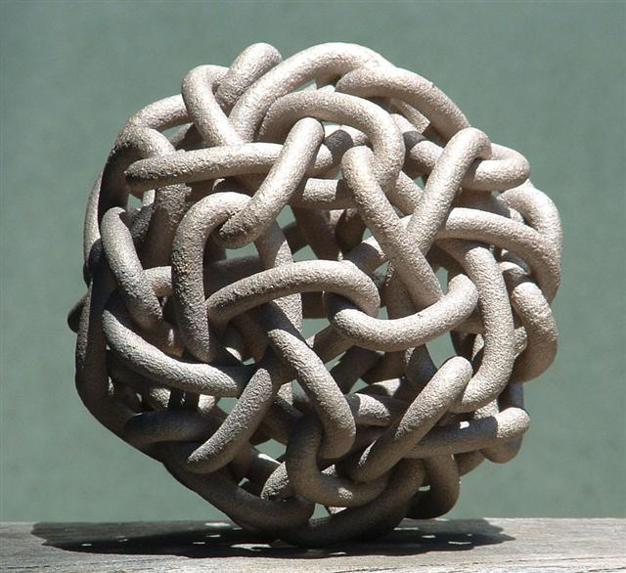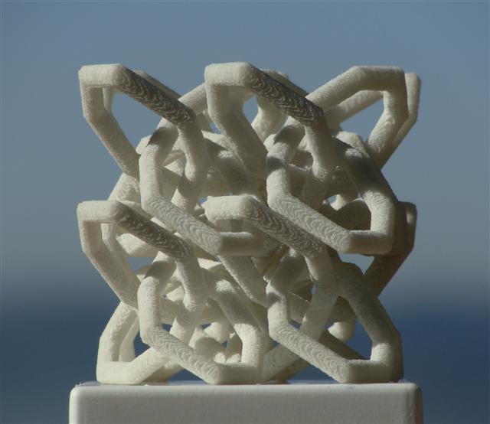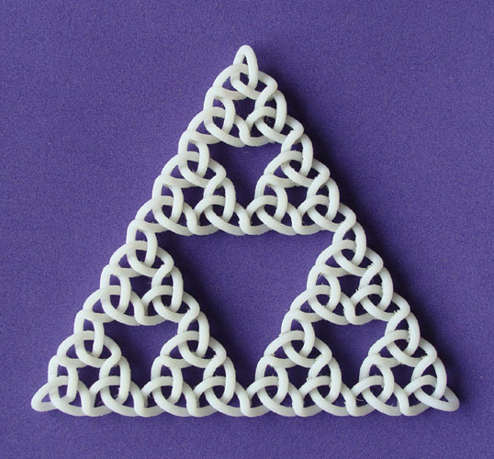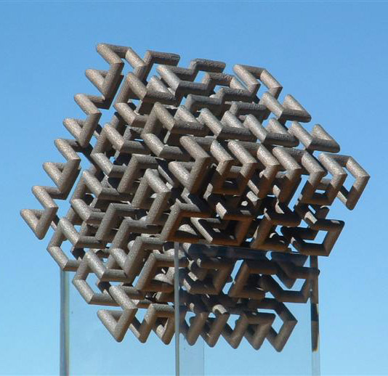

Figure 2: Here is a more extended caption that is left/right-justified. It has multiple components that are referred to from left to right. Knotty Sculptures: (a) Hilbert Cube, (b) Dodeca-Pentafoil, (c) Recursive Trefoil Knot, and (d) Lattice of Figure-8 Knots.

Tables should be inserted close to their reference, centered, and captioned, just like figures. Table captions are the same as figure captions, e.g., Table 1, Table 2, etc., or Table 1(a), Table 1(b), etc. Table captions should be in 9-point Sans Serif. Cell entries can be centered or left/right-justified. Please follow the same format as for the figures. Put a blank line before and after the table.

Date | Code | Amount
3/10/2004 | HS_129 | 234.44
3/11/2004 | LL_78 | 12.98

Table 1: Again, short captions should be centered under each table.

Mathematics
Math typesetting should be done by Math Type. Style settings (define) for Math Type are as follows:
- Primary font: Euclid
- Greek and math fonts: Euclid symbol and Euclid extra
- Italic variables and italic lower-case Greek

Size settings (define) are these:
- Full 9pt
- Sub/super 6pt
- Sub-sub/super 4pt
- Symbol 16pt
- Sub-symbol 10pt
- User 1 75%
- User 2 150%
Symbols and shorter expressions can be placed within the text, e.g., . More complex expressions should be placed in a new line in display style:
(8.1)
All equations must be centered and numbered according to the section they appear. They should be referenced just like figures, e.g., Equation (8.1).

References and Citations
References should be listed alphabetically at the end of the paper. The listing and the citations should be done by numbers in brackets, e.g., [1]. Block references are allowed in the form [3-6]. Single and block references can be combined, e.g., [1],[3],[5-9],[15]. The typesetting of references should follow the format given at the end of this document. They should be published materials accessible to the public with reasonable effort and without significant expense. References to be avoided are:
- private communications;
- technical reports, unless they are available, e.g., downloadable from a website;
- proprietary information/documents;
- dissertations, unless they can be obtained for free, e.g., downloadable from a website;
- all non-English publications; and
- non-archival speeches and presentations.
References can include the usual material, e.g., journal articles, conference papers (refereed or non-refereed), and books or book chapters. In addition to these, acceptable references also include websites, e-papers, accessible government documents, e.g., patents, and all audio-visual materials, e.g., VR simulation, that are available to the public either electronically or in hard copy format, e.g., on a CD.

Footnotes
The footers in this template are reserved for journal citation purposes. Please avoid using footnotes. Do it within the text if an explanation is required for an abbreviation or a term.

ORCID

Each author should have an ORCID (http://orcid.org). Please insert the ORCID link into the icons next to your name. Also, please list the ORCID links for each author as listed below.

John C. Gotti, http://orcid.org/[ORCID]
Jessie A. James, http://orcid.org/[ORCID]
Donald L. Corleone, http://orcid.org/[ORCID]

REFERENCES
- Adams, S.-H.; Yang, M.-Y.: A study on a generalized parametric interpolator with real-time jerk-limited acceleration, Computer-Aided Design, 36(1), 2004, 27-36. http://doi.org/10.1016/S0010-4485(03)00066-6
- Bates, J.; Ding, M.-S.; Park, J.: A Study on Rapid Prototyping Techniques, TR UMCP-97-003, University of Massachusetts, Boston, MA, 1997, http://www.um.edu/~bates.html.
- Debra, N. L.: Principles of Mechanical Design, Oxford University Press, New York, NY, 1990.
- Eaton, J. A.: Layered Manufacturing Methods for Reconstructing Bone Structures, Ph.D. Thesis, University of Minnesota, Twin Cities, MN, 1998.
- Hepworth, A. I.; Nysetvold, T.; Bennett, J.; Phelps, G.; Jensen, C. G.: Scalable integration of commercial file types in multi-user CAD, Computer-Aided Design & Applications, 11(4), 2014, 459-467. http://doi.org/10.1080/16864360.2014.881190
- Jewelspace, http://www.jewelspace.net, Caligari Software.

Please follow the format shown above. That is:
- author names are listed by the last name;
- multiple authors are separated by a semi-colon;
- after the last author’s name, place a colon;
- list the title and the journal separated by a comma; and
- the journal details are Volume (Issue), Year, and Pages.
Please list the title, publisher, place, and year of publication for books, thesis, etc.

